Declaration of Academic Integrity
Academic Integrity is a central tenet of Singapore Polytechnic. The polytechnic rules state that "Cheating in examinations and other assessed work is a very serious offence. This includes copying and using plagiarised material. Any student who cheats, attempts to cheat or breaches any rules for examinations and tests will face disciplinary action. The student is liable to be expelled."
Check only one of the two options below:
☐ I affirm that the work I submit is my own, produced without help from any AI tool(s) and/or other source(s).
☐ I affirm that the work I submit has been produced with the use of AI tool(s) and/or other source(s) which I have acknowledged fully in the following section.
By signing this form, I declare that the above affirmation made is true, and that I have read and understood the rules stated in Students Handbook on “Plagiarism” and “Breach of Examination/Assessment Rules”.

Name:  Kong Cheng Sheng | Student ID:  2026044 | Class:  DIT/FT/1B/11
Signature:  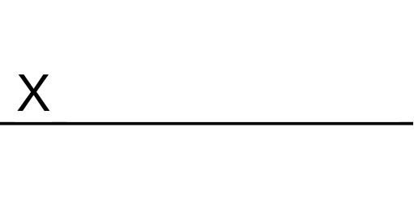 | Date:  11/1/2026

Acknowledgement of use of AI tool(s) and/or other source(s) (where applicable)

AI tool(s)
Name of AI tool | ChatGPT
Input prompt | How can I make a neat display in javascript?
Date generated | 5/1/2026
Output generated | padEnd() is great for making clean, column-aligned text output (like tables in the console).
Impact on submission | ChatGPT has taught me that using padEnd() can provide a simple and neat column display which is being used in my CA1’s UI.

Other source(s)
Source | Impact on submission
< Link to online source > | < Briefly explain which part of your submitted work the online source was applied >
< Author, Book / Article / Journal, Year, Pages > | < Briefly explain which part of your submitted work the Book / Article / Journal was applied >
< Student / Person name > | < Briefly explain which part of your submitted work the help of another student / person was applied >
< Others > | < Briefly explain which part of your submitted work the source was applied >

